**CNN Math**

-CNNs are used to recognize visual patterns directly from pixel images with variability.

-CNNs are special types of multilayer neural networks. They are trained with the back-propagation algorithm.

-CNN is a special form of the feedforward neural network (FNN), also known as the multi-layer perceptron (MLP), trained with back-propagation.

<https://www.analyticsvidhya.com/blog/2020/02/mathematics-behind-convolutional-neural-network/?utm_source=blog&utm_source=learn-image-classification-cnn-convolutional-neural-networks-5-datasets>

-Convolutional neural network (CNN) – almost sounds like an amalgamation of biology, art and mathematics

-few popular computer vision applications where CNNs are used: Facial recognition systems, Analyzing and parsing through documents, Smart cities (traffic cameras, for example) and recommendation systems, among other use cases

<https://hackernoon.com/the-full-story-behind-convolutional-neural-networks-and-the-math-behind-it-2j4fk3zu2>

-The whole Idea of Convolutional Neural Networks is inspired by the biology of the eye. While we as humans perceive a visual image as a detailed, coloured image of the world around us, there is actually quite a lot of processing done in our brain to get to this point

-CNN try to use this concept of combining low-level features in the image to higher and higher-level features.

<https://courses.analyticsvidhya.com/courses/convolutional-neural-networks-cnn-from-scratch?utm_source=blog&utm_medium=mathematics-behind-convolutional-neural-network>

-A Convolutional Neural Network is a powerful neural network that uses filters to extract features from images. It also does so in such a way that position information of pixels is retained.

-A convolution is a mathematical operation applied on a matrix. This matrix is usually the image represented in the form of pixels/numbers. The convolution operation extracts the features from the image.

-CNNs have proved particularly successful in working with image data and ever since being used in ImageNet competition in 2012, they have been the frontrunners in research and industry while dealing with images.

-CNN is better than ANN because While solving an image classification problem using ANN, the number of trainable parameters increases drastically with an increase in the size of the image. Convolutional Neural Networks captures the spatial features from an image, which ANNs fail to do so.

-Popular frameworks support Convolutional Neural Networks like Tensorflow-Keras in Python.

-We need three basic components to define a basic convolutional networ: The convolutional layer, The Pooling layer[optional], The output layer.

<https://qiita.com/Rowing0914/items/e815ca24427874030526#math-in-cnn> – math formulas

As you probably know, the network composes many neurons in layers. And each layer is connected by its pipeline. So first the input data is propagated forward through layers till the output layer. Then in order to strengthen the ability to represent the dataset, the net needs to learn by tuning its parameters measuring the error between the target and its prediction. Hence in this section we will see two faces of the layers, forward-propagation and back-propagation.

-Three Key Features in CNN: Convolutional layer, Activation layer, Pooling layer(generally we apply max-pooling)

-Convolutional layer:

Max Pooling:

-Multi-channel Convolutional layer: It's good time for us to move on to more practical nets.

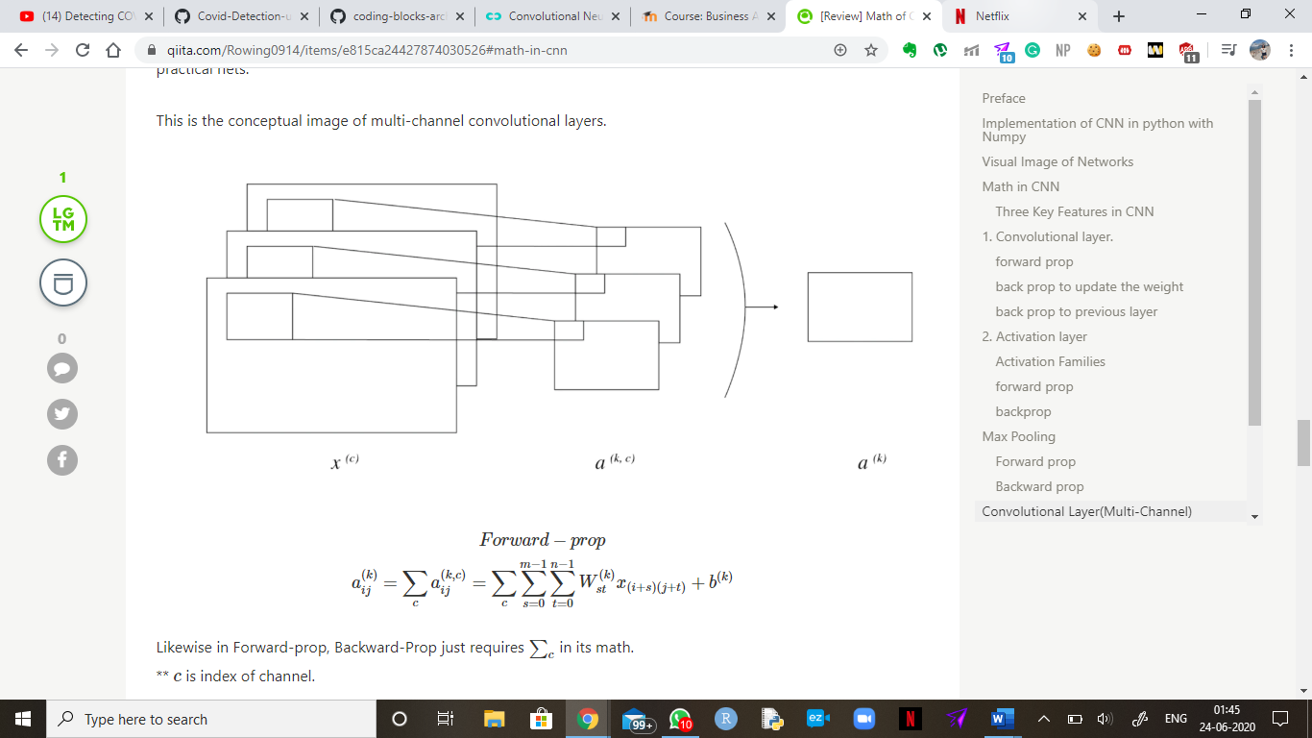

CNN Math – Dissertation

Convolutional Neural Network (CNN) is a robust deep learning algorithm, mainly used to identify and classify images. CNN is a distinctive type of neural network in which analyses visual inputs to identify for segmentation, detection, and classification. The concept is based on combining low-level features in the image to higher and higher-level features. The filters extract features from images in such a way that the position information of pixels is retained. The algorithm is mainly used for face recognition, analysing documents, managing traffic in smart cities, and recommendation systems.

CNN is trained on the back-propagation algorithm. After we get the output from Forward propagation, the actual value is compared with the output to calculate the error rate. The parameters are then updated, and the entire process is repeated to get the optimal values. (<https://www.analyticsvidhya.com/blog/2020/02/mathematics-behind-convolutional-neural-network/?utm_source=blog&utm_source=learn-image-classification-cnn-convolutional-neural-networks-5-datasets>)

CNN is an amalgamation of biology, art, and mathematics. The biology of the eye inspires the entire architecture. CNN mimics the connectivity of neurons within the brain. While we as humans perceive a visual image as a detailed, coloured image of the world around us, there is quite a lot of processing done in our brain to get to this point.

CNN has proved particularly successful in working with image data and ever since being used in ImageNet competition in 2012. They have been the frontrunners in research and industry while dealing with images.

<https://courses.analyticsvidhya.com/courses/convolutional-neural-networks-cnn-from-scratch?utm_source=blog&utm_medium=mathematics-behind-convolutional-neural-network>

CNN can also be used for deep learning applications in healthcare, such as medical imaging. CNN has been used for features learning on breast ultrasound images, blood analysis, brain lesion segmentation, detection of Alzheimer’s and Parkinson’s Diseases, tumour, lung cancer, pneumonia, and various other diseases.

(<https://arxiv.org/ftp/arxiv/papers/1704/1704.06825.pdf>)

The neurons within a CNN are split into a three-dimensional structure, with each set of neurons analysing a small region or feature of the image. In other words, each group of neurons specializes in identifying one part of the image. CNNs use the predictions from the layers to produce a final output that presents a vector of probability scores to represent the likelihood that a specific feature belongs to a certain class.

<https://missinglink.ai/guides/convolutional-neural-networks/convolutional-neural-network-architecture-forging-pathways-future/>

CNN is composed of several kinds of layers:

1. **Convolutional layer**: This layer3 consist of Image Filters that extract patterns from the image. What information these filters extract is learned, just like in the brain. When we train a Convolutional Neural Layer, we try to generate the best possible filters, e.g. the filters that extract the most meaningful information.

Convolutional layers detect low-level features such as edges and curves. This layer creates a feature map to predict the class probabilities for each feature by applying a filter that scans the whole image, a few pixels at a time.

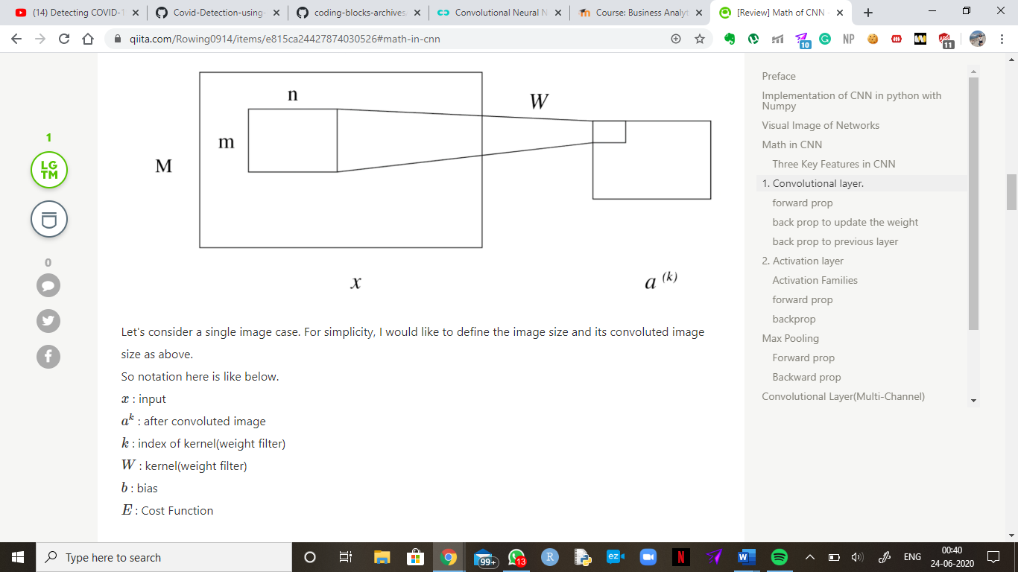

CNN follows the forward propagation procedure in which the weights, biases and filters are inputted, processed and passed on to its successive layers. These values act as parameters of the CNN model.

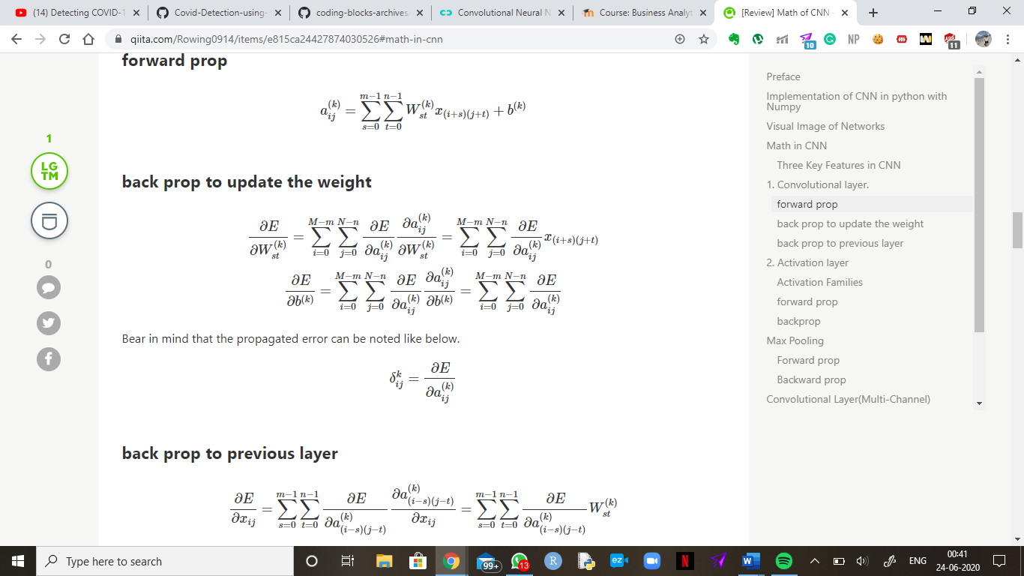

The activation function is the non-linear transformation that we do over the input signal. This transformed output is then advanced to the next layer of neurons as input. When it comes to the selection of activation functions, indeed we have some options, for example, ReLU, sigmoid or hyperbolic tangent.

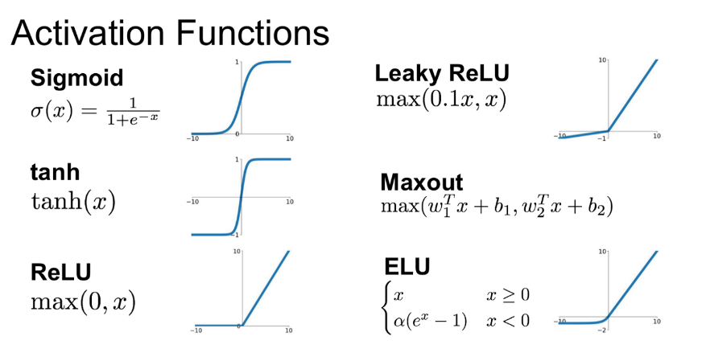

|  |  |
| --- | --- |
| Function | Formula |
| Sigmoid | Abc |
| Tanh | Def |
| ReLU | Ghi |
| Leaky ReLU | Abc |
| Maxout | Def |
| ELU | Ghi |

ReLU function is the most widely used activation function in neural networks. ReLU converts all negative inputs to zero, and the neuron does not get activated, making it very computational efficient as few neurons are activated per time. It does not saturate at the positive region. The ReLU activation functions is used for the hidden layers.

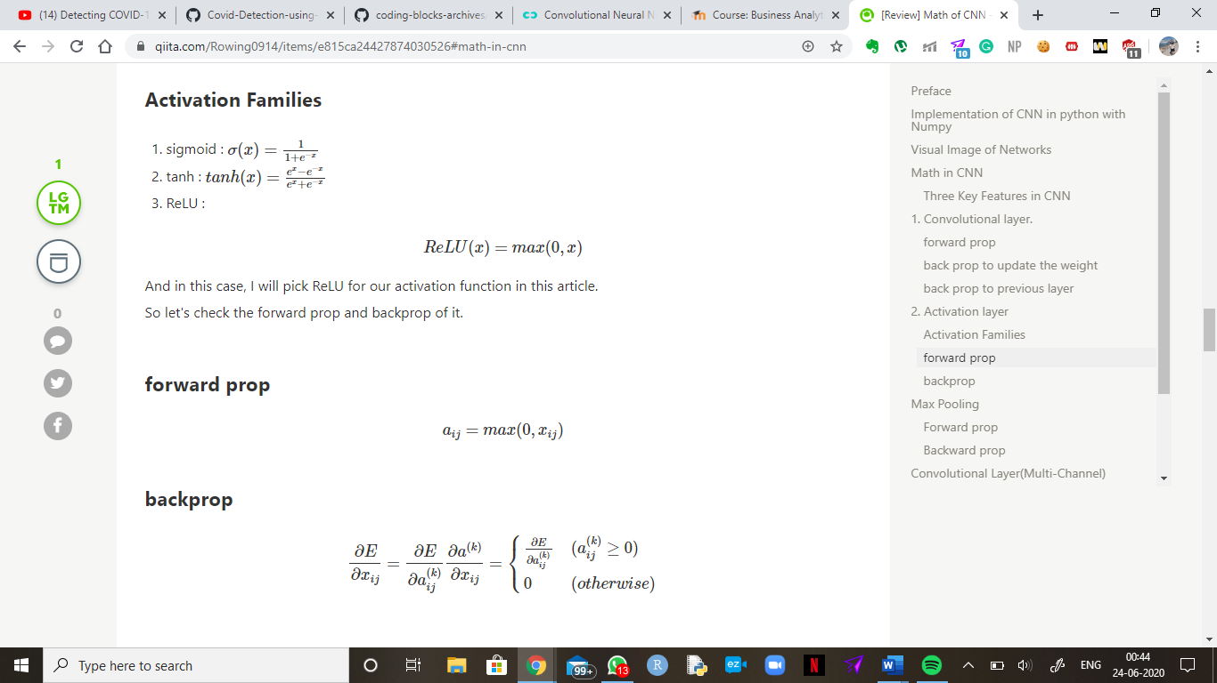

2 - Pooling Layer (down-sampling): Even though the size of the images will slightly decrease with each filter in each layer, we generally generate exponentially more and more data with each convolutional layer we add. To combat this issue, we use a process called Pooling. In this layer, the amount of information generated by the convolutional layer is scaled-down and only saves crucial information. Most prominently, we use Max Pooling, meaning we take the maximum pixel value of a pixel neighbourhood.

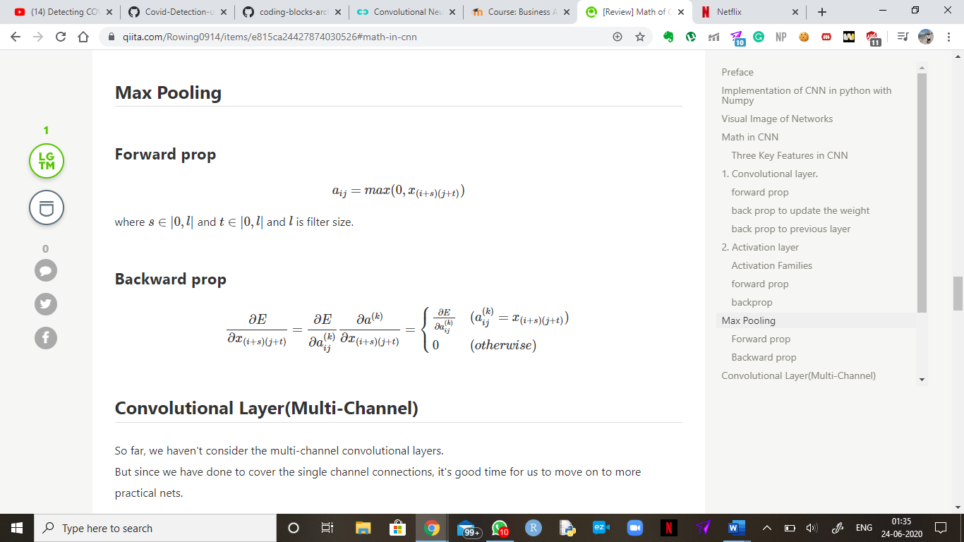

3 - Fully connected layer: This layer “flattens” the outputs generated by previous layers to turn them into a single vector that can be used as an input for the next layer. It converts a two-dimensional convolutional layer into one dimension which can be used to connect to the fully connected layer. The weights are applied over the input generated by the feature analysis to predict an accurate label.

4 - Fully connected output layer: A fully connected layer uses the output of the convolution layer to predict the best description for the image. This layer generates the final probabilities to determine a class for the image.

Sigmoid function is a S-Shaped curve which is differentiable and monotonic in nature, existing between 0 and 1. The sigmoid activation function is used for the output layer because there is a distinction to be made between two classes.

A technique called forward-backward propagation is used to check and optimize the performance of the model. In forward propagation, the input data is fed in the network, and the output data is generated. The loss is calculated to see how far away the prediction of the network is from the actual value. We calculate the cross-entropy error of the model: 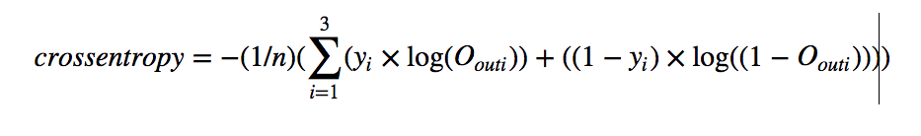

In the backward propagation process, the parameters of the model are updated in a manner that the overall predictions are more accurate than the previous model. This composition has to be optimized on a per-layer basis. The error can be propagated back from the end to the start by de-stacking through the function calls. This technique is called auto-differentiation and requires only that each function is provided with the implementation of its derivative.

T



Back propagation of ReLU activation:



Back-propagation of the Pooling Layer:



Back-propagation of the Sigmoid Layer: